Business Report
Austo_Automobile

Submitted by-Shweta Aggarwal

CONTENT
Problem 1-Data Overview
1.1 Import the libraries
1.2 Load the data
1.3 Check the structure of the data
1.4 Check the types of the data
1.5 Treating missing values
1.6 Check the statistical summary
1.7 Data irregularities
1.8 Observations and Insights
Problem-1
Austo Motor Company is a leading car manufacturer specializing in SUV, Sedan, and Hatchback models. In its recent board meeting, concerns were raised by the members on the efficiency of the marketing campaign currently being used. The board decides to rope in analytics professional to improve the existing campaign.
Objective
They want to analyse the data to get a fair idea about the demand of customers which will help them in enhancing their customer experience. Suppose you are a Data Scientist at the company and the Data Science team has shared some of the key questions that need to be answered. Perform the data analysis to find answers to these questions that will help the company to improve the business.

Problem-1 Data Overview
1. -1 Importing the libraries
To analyse the data set using python, we have uploaded all the necessary libraries like Pandas, NumPy, Seaborn and Matplotlib.
1.2 Load The Data-
Loading data is the initial step in any data analysis project. It about bringing data inside Jupiter Notebook for analysis. Here is brief description for loading data in python.
1.3 Check the structure of the data-
Checking the structure of the data is crucial step to understanding its format, features, and initial characteristics. I have used df. head(), df.info() and df. shape().
Dataset_Name-austo_automobile.csv
Total Number of Rows-1581
Total Number of columns-14
Top 5 rows of dataset
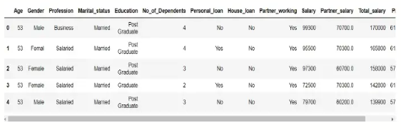
1.4 Check the types of the data -We have 6 numerical and 8 object data types.
1.5 Treating missing values – In this dataset we can see the missing values are in Gender column and Partner salary column.
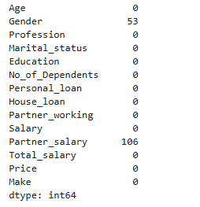
I have replaced missing values in Gender Column with Mode and Partner Salary =Total salary-Salary.
1.6 Check the statistical summary
I have used describe () function to check the statistical summary.
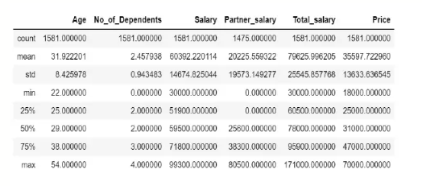

1.7 Data irregularities
There are no duplicates value in the Dataset. There were two spelling error in dataset femal and femle I replaced those spelling using replace function.
1.8 Observations and Insights- In the given dataset there is null values in Gender and partner salary. There are no duplicate values in the dataset. Also, there is spelling error in gender data set.
The average age is approx..31.92yrs.
The ages range from a minimum of 22 yrs to maximum of 54yrs.
The average number of dependants is approx. 2.46.
The average salary is approx.60,392
The standard deviation for total salary is higher than that for individual salary which is expected as it combines two salary sources.
Univariate Analysis
Explore all the variables (categorical and numerical) in the data –
We have eight categorical variables here -Gender, Profession, Martial status, Education, personal loan, House_loan,Partner_working,Make

We can clearly see that buying pattern for car younger age (20-30) tends to buy more car as compared to middle age (31-41) and older age (42-53)
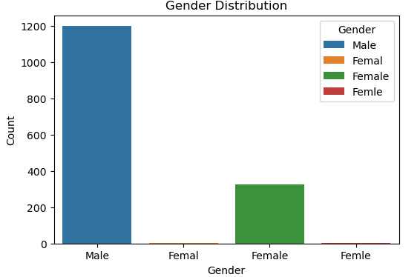
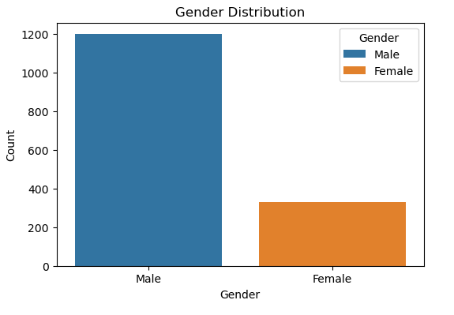
The bar for the Male category shows a count of approx. 1200.The bar for the Female category shows a count of approx. 300

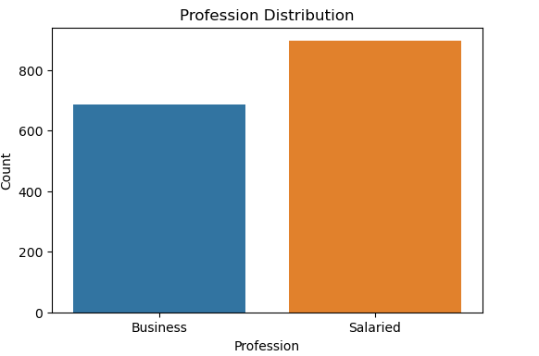
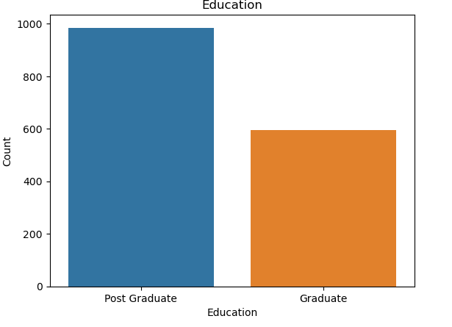

From above count plot we can see that post graduate customer are more than graduate. Also, most of the people are salaried.

Numerical Variables-
Age Distribution-We can clearly see that buying pattern for car younger age (20-30) tends to buy more car as compared to middle age (31-41) and older age (42-53)

Price distribution has two peaks which means prices are mostly around 30-35k and 50-55k.This suggests that there are two popular price ranges for car.
This helps understand customer preferences most buyers choose cars in the mid-range segment ,while some prefer higher-priced .
Partner salary – Most partner earn a moderate income mainly between 30000 and 45000, indicating that this is the common salary range among partners.
Total salary -Most salaries fall between 80000 and 90000 with a small number of higher earners extending the right tail of the distribution.
Salary Distribution-The salary distribution peaks around 55000-60000 showing most individuals earn mid-range salaries while high salaries are less common.

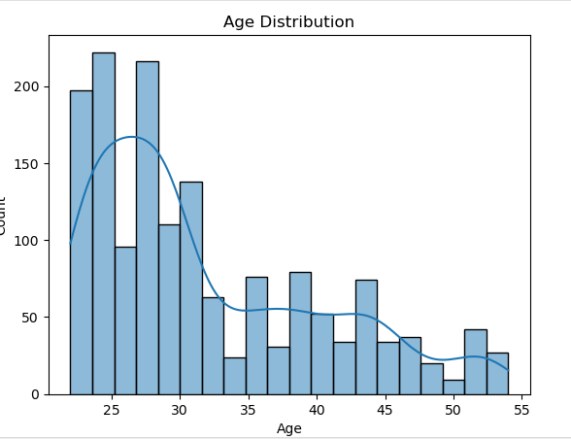

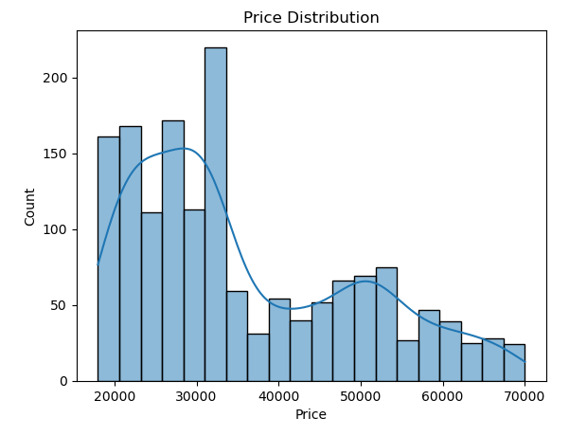
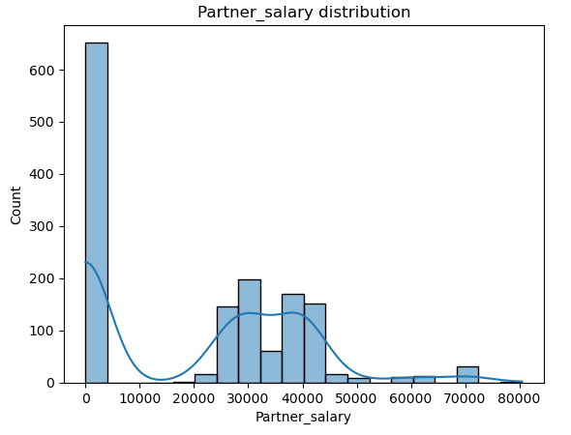
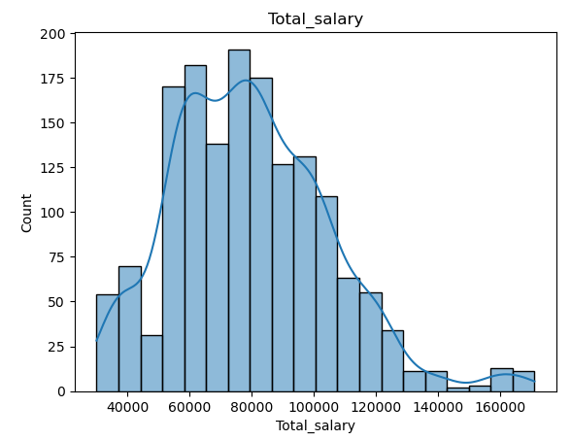
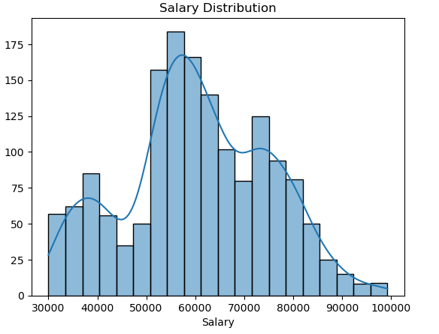

Check for and treat (if needed) outliers
There are outliers in total salary column and no. of dependents column. I have removed outliers using IQR method. Replace the values with lower whisker or upper whisker values.

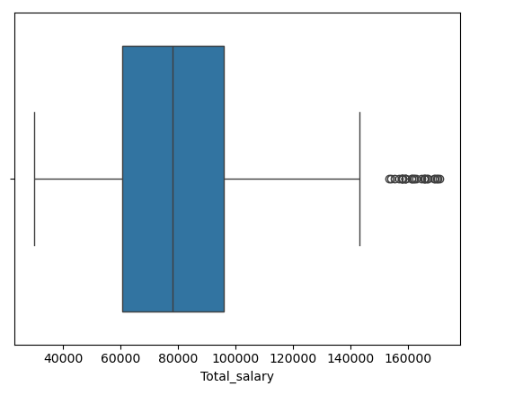
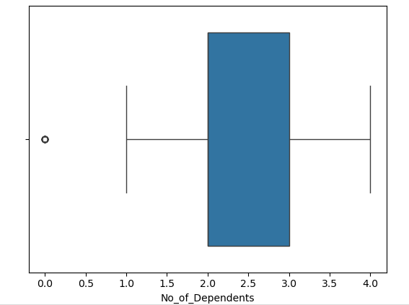
Observation And Insights- Most people are between 25 and 38 yrs old. In this data most people are working.
Salaries vary but mostly fall between 50k and 70k.
Bivariate Analysis
Explore the relationship between all numerical variables-
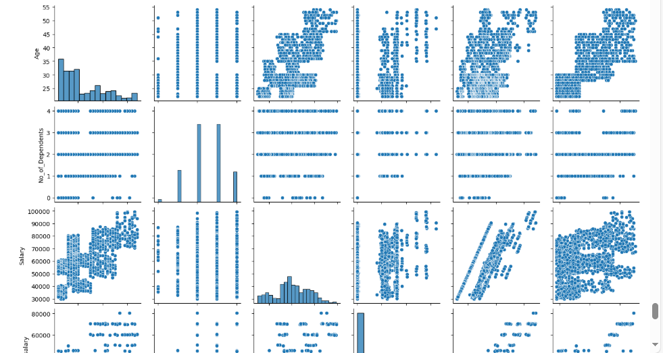
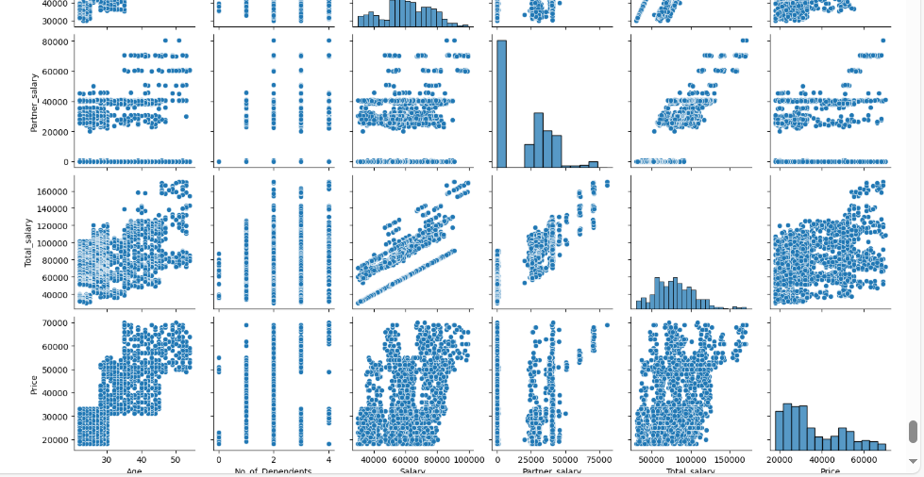
A pair plot is used to visualize the relationship between all numerical variables in the dataset. The chart displays pairwise relationships. Helping to identify patterns and correlations.
No strong link between most variables. younger buyers prefer lower priced cars.
More dependents slightly buy cheaper car.
Explore the correlation between all numerical variables-
The correlation heatmap provides a visual representation of the correlation matrix for all numerical variables. This visualization enables easy identification of patterns, strong relationships, and potential multicollinearity in the data.
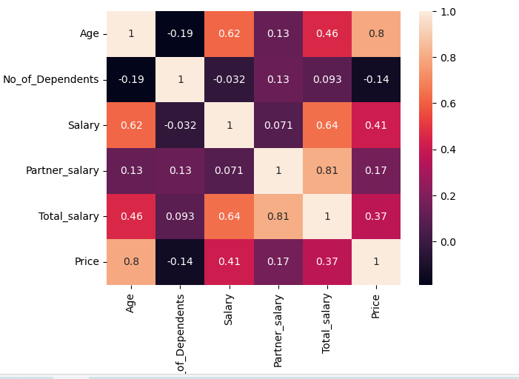
+1-indicates positive correlation
-1 indicates negative correlation
0 indicates no correlation

Explore the relationship between categorical vs numerical variables-
Relationship between categorical vs numerical variables using bar plot.
No of dependents vs price- Average price varies with the number of dependents. The average price is highest for 1 dependent and the lowest value observed for 3 dependents.
Personal loan vs price- The graphs indicate the number of individuals without a personal loan is greater than the number of individuals with a personal loan.
House loan vs Price- The bar for the yes category is shorter indicating a lower average price. The average price is higher when a house loan is not involved and lower when a house loan is involved.
Total salary vs Make – Individuals who own SUVs tend to have the highest total salaries, followed by those with sedans, while Hatchback owners have the lowest total salaries among the three categories.
Education vs Salary- The bar for post graduate is noticeably taller than the graduate bar .so we can observe that post graduate degree earns more than those with only a graduate degree.
Make vs Age- owners of SUVs tend to be older on average, followed by Sedan owners, while hatchback owners are the youngest among the three groups.

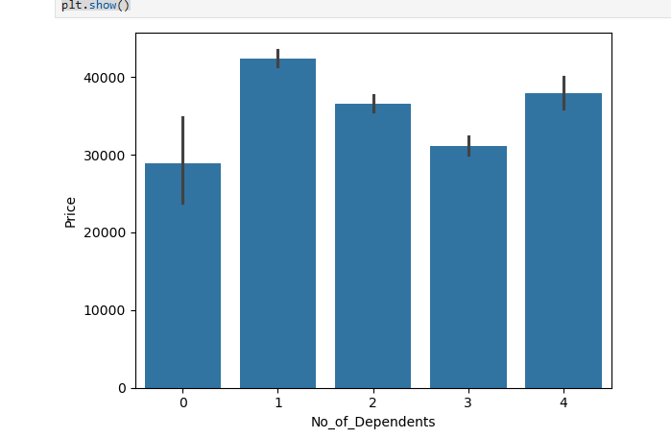

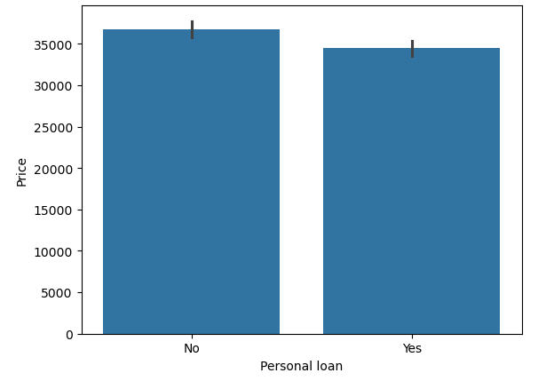
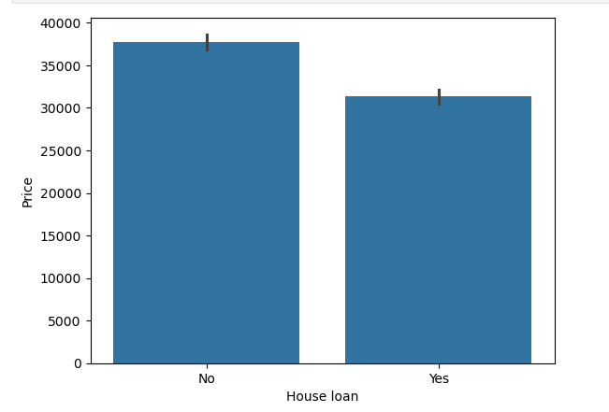

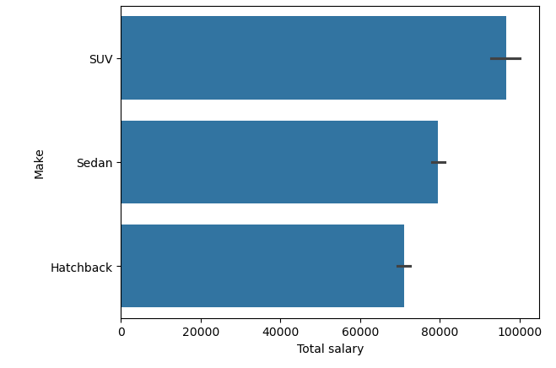

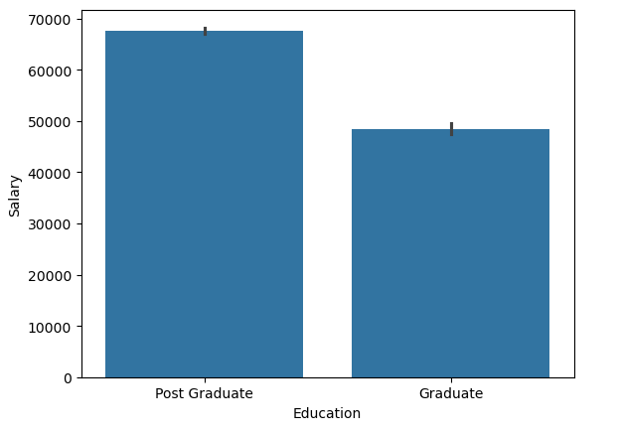
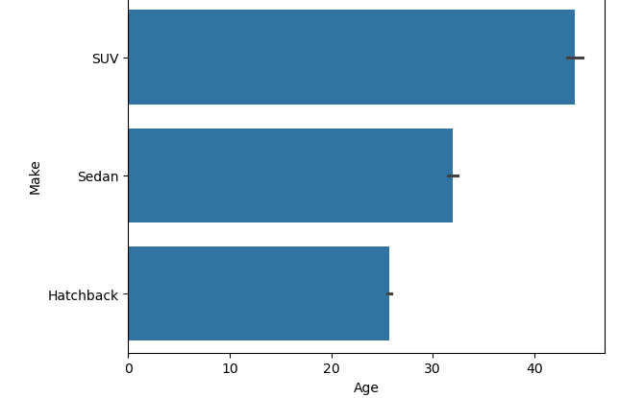

Criteria Key Questions Explore the data to answer the following key questions:
1. Do men tend to prefer SUVs more compared to women?
No, Female tend to prefer SUVs more compared to men.

2. What is the likelihood of a salaried person buying a Sedan?
The analysis indicates that the probability of a salaried individual purchasing a sedan is higher than that of purchasing other categories of cars.
3. What evidence or data supports Sheldon Cooper's claim that a salaried male is an easier target for a SUV sale over a Sedan sale?
The analysis reveals that salaried males are less likely to purchase SUVs compared to sedans.
4. How does the amount spent on purchasing automobiles vary by gender?
The analysis reveals that females tend to spend more on SUVs compared to males. Furthermore, the total expenditure on sedans is nearly three times higher than the amount spent by female customers.
5. How much money was spent on purchasing automobiles by individuals who took a personal loan?
Total money spent on purchasing automobiles by individuals who took a personal loan=27290000

6. How does having a working partner influence the purchase of higher-priced cars?

So, there is less effect on the purchase made on higher priced cars.
Actionable Insights and Recommendations.
Single customers (Unmarried)- Higher average car prices among single buyers suggest a preference for premium or luxury models. Marketing should highlight advanced features and modern design.
Married customers=Married buyers tend to prefer family-oriented or SUV models emphasizing space, comfort, and safety. Campaigns should focus on practicality and reliability.
Gender based insights- comparing purchase prices across gender and martial status can reveal unique preferences.
Customers with Loan-people who take a loan to buy a car may prefer budget friendly or mid-range models. Marketing can focus on easy EMI plans, low interest rates, and value-for-money options.
Customers without Loan-Those who buys cars without a loan may have higher income and prefer premium or luxury cars. Campaigns can highlight advanced features, comfort and status value.
Loan customers look for affordability, while non-loan customers focus on quality and features.

Thank you

